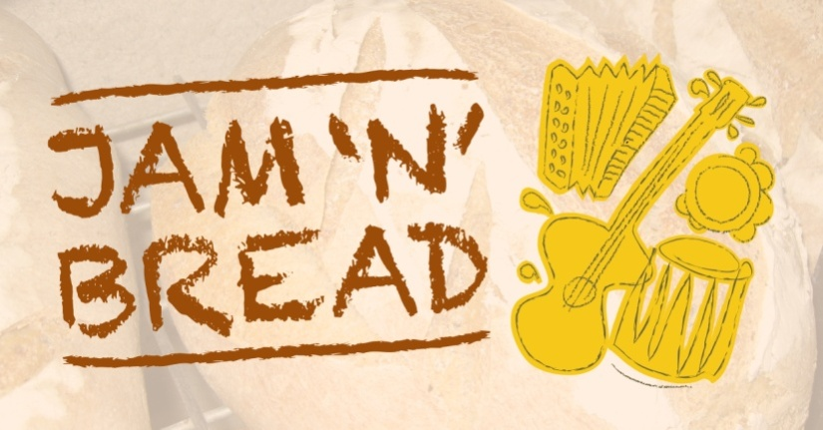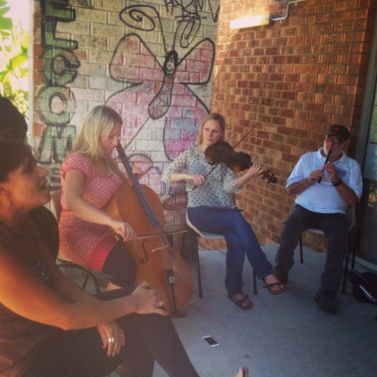

Come sing, play, bake bread, feast and share culture at Jam n Bread's monthly community music making gatherings at the Port Kembla Community Centre, Corner of Church & Wentworth St.

All ages & all abilities welcome. Some instruments provided or bring your own.

The next Jam n Bread session will be an open jam. Come and share your music. Our grant funding has ended so we will be inviting people to give a gold coin donation for the bread.

Next date:
Sat 21st March 12 noon-3pm coinciding with Harmony Day and the biggest slip n slide in Illawarra's history- The Port Kembla City Slider

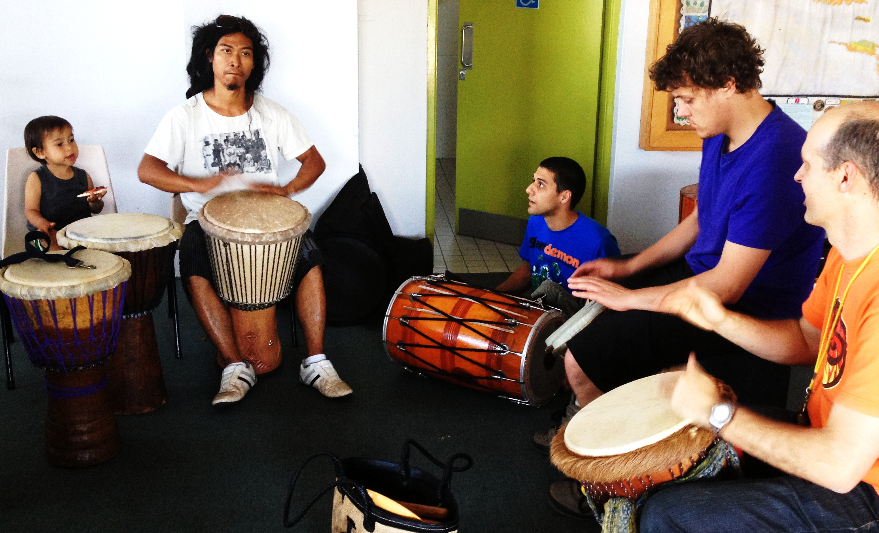
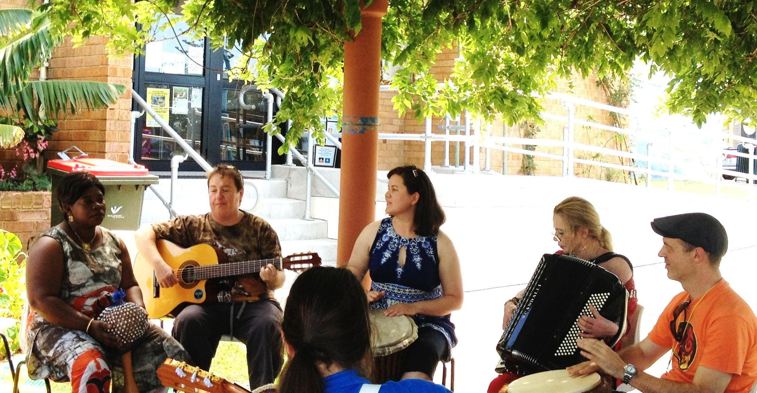

https://www.facebook.com/pages/Music-Jam-n-Bread
Ann Lehmann-Kuit 0414 680123 musicjamnbread@gmail.com

